Breadth-first search

Concept :-

A graph traversal means visiting all the nodes of the graph.
OR
By traversing a graph, we mean the method of examining the nodes and edges of the graph. There are two standard methods of graph traversal. They are:

1) Breadth-first search : uses queue to store nodes for further processing.
2) Depth-first search : uses stack.

Question: Implement breadth-first search given a source node in a graph using Python.
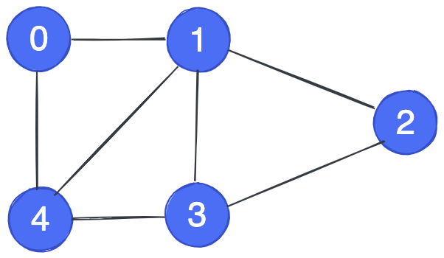

Flow chart :-

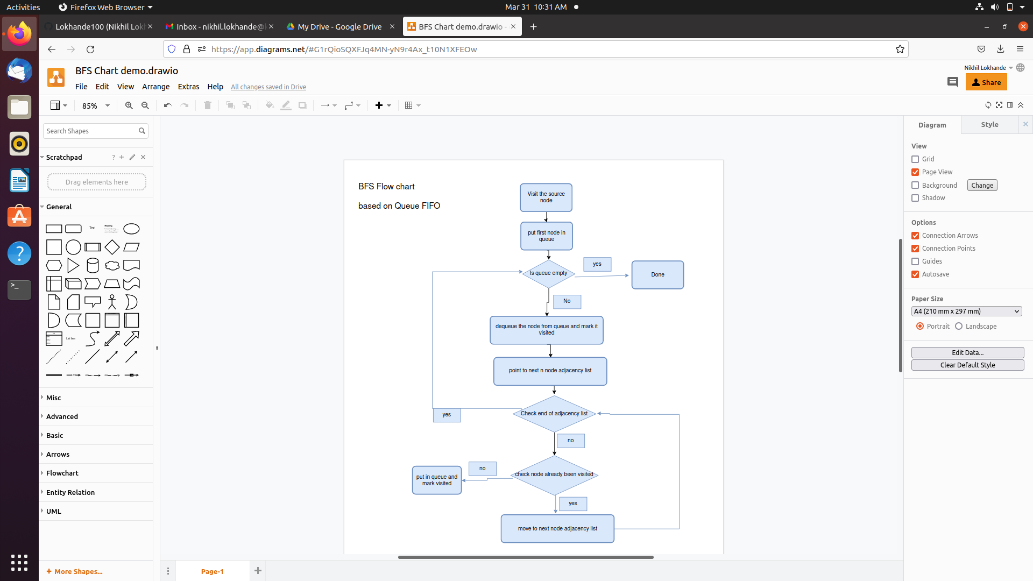

Flow chart :-

Considering 4 is a source code:-

The traversing will start from the source node and push 4 in queue. 4 will be marked as 'visited'.
- visited 4
- queue 0,1,3

Second iteration
- visited 4 ,0
- queue 1 ,3,2

Third iteration
- visited 4 ,0,1
- queue 3,2

Fourth iteration
- visited 4 ,0,1,3
- queue 2

Fifth iteration
- visited 4 ,0,1,3,2
- queue Empty

The queue is empty and it comes out of the loop. All the nodes have been traversed by using BFS.

Program :-

graph = {
'0' : ['1','4'],
'1' : ['0', '2','3','4'],
'2' : ['1','3'],
'3' : ['1','2','4'],
'4' : ['0','1','3'],
}

visited = [] # List visited nodes.
queue = [] # queue

def bfs(visited, graph, node):
visited.append(node)
queue.append(node)

while queue:
m = queue.pop(0)
print (m, end = " ")

for neighbour in graph[m]:
if neighbour not in visited:
visited.append(neighbour)
queue.append(neighbour)

print("Breadth-First Search")

Complexity
The time complexity of BFS is O(V + E), where V is the number of nodes and E is the number of edges.

